**Name:** Siddhant M Mangale  
**Class:** B.Tech **Div:** A  
**Roll No:** 31

**Experiment No. 4**

Aim: Julia Programming based on Julia Ecosystem Packages

1. Implement Julia Program using Graph Theory Packagejulia> Pkg.add("FunctionalCollections")

julia> using FunctionalCollections

1. Implement Julia Program using Graphics Packages.  
   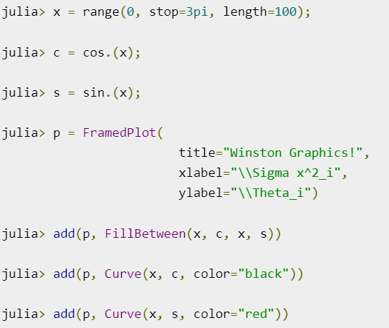

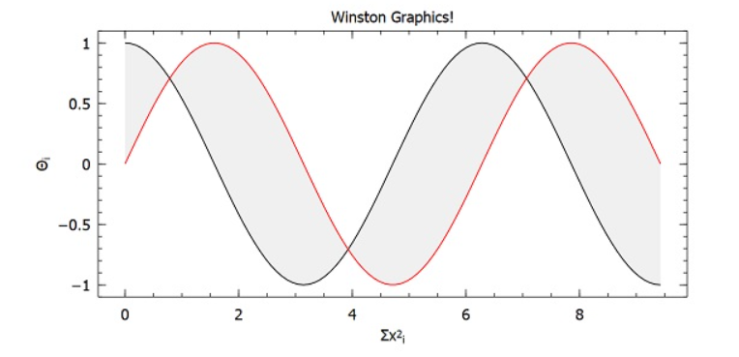

1. Implement Julia Program using Math Package.  
   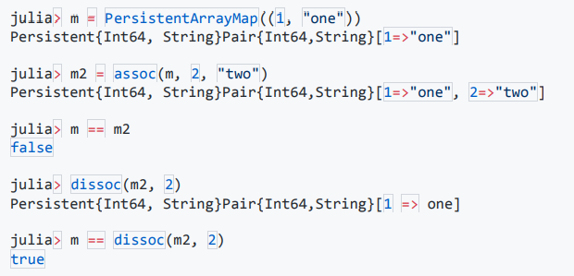
2. Implement Julia Program using Optimization  
     
   